EVELYN OGILVIE SPINK 1905-1976
On the centenary of her birth

Evelyn Helen Mary Scarlett was born on December 24, 1905 in Bodie, California, USA. Bodie, now preserved as a museum and state park, was a gold mining town situated high in the Sierra Nevada Mountains. Evelyn’s father, John Edwin Scarlett (known as Jack), a Canadian and Secretary Treasurer of the mine and his English wife, Annie Elizabeth, nee Byner, named her for the day she was born, on Christmas Eve. Evelyn and her younger brother, Yorke, lived in Bodie for several years before the family moved to Devon in England. Evelyn went to school at the Convent of the Assumption in Sidmouth where her cousin, Ellen Landsell, who had converted to the Roman Catholic faith, was a nun. At school, Evelyn was known as the “Scarlett runner bean” for her height, 5’11” and her athletic ability – she was an avid tennis player.
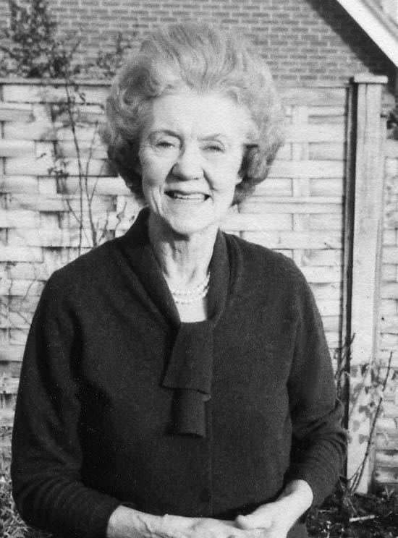

After Evelyn left the convent she moved to London and worked for Vogue Magazine where she traveled throughout the country demonstrating the use of Vogue patterns in dress-making. At the age of 31 she married George Hamilton Ogilvie. They lived in Swallowfield, near Reading in England and had two children, John William, born in April 1938 and Rachel Anne, born in September 1939. George, a Lieut. Colonel in the Ghurka Regiment before his marriage, was honored by King George V for his service in Burma during World War I. He died in 1943 at the age of 57.

Evelyn moved to London with the two children to start a career as a buyer at Fenwick’s, a large department store. It must have been hard for a young widow to leave the
Page 2

countryside and move to London, get a job and bring up two children on her own. Her sister-in-law, Juliet Ogilvie, joined the family at 47 Barkston Gardens to help with the children.

Evelyn had a natural flair for fashion. She was always impeccably dressed and took pride in her appearance. She had an infectious laugh and a great sense of humor. Evelyn loved company, was easy to talk to and was never at a loss for words. She would tell stories about her childhood in Bodie, the hot sulphur springs coming right out of the ground and how, in the winter, she would ski to school.

Some time in the 1950’s Evelyn moved to Worthing in Sussex where she met and married Douglas Spink (Dougie). They were married only a few years when Dougie was diagnosed with lung cancer and died shortly thereafter. Evelyn continued to work in the fashion industry and enjoyed visits with Yorke and his family. She went out to America several times to visit Rachel, her husband Robert Godfrey, and their two daughters Nicola and Emma. Evelyn’s son, John, married Dana Laganowska in 1963 and Evelyn enjoyed being with them and their children Rachel, Helen, Cathy, Davina and Philip. Evelyn died suddenly of an aortic aneurism on March 17, 1976 at the age of 70.

This is the essence of a strong, hard-working, energetic and indefatigable woman. She has shaped my life in many ways and I hope I have been able to pass on some of her qualities to my children. She lives on in my heart and mind. While rummaging through some old treasures the other day, I found her wedding ring and slipped it on my finger. It was a perfect fit.

Rachel

December 24, 2005

